

**CSE - 310**

**LAB REPORT-08**

**Submitted By:**

**Name: Md. Zobayer Hasan Nayem**

**ID: 19202103274**

**Intake: 44**

**Sec: 08**

**Submitted To:**

**Teacher Name: Ali Azgor**

**Assistance Professor**

**Dept. of CSE**

**Bangladesh University of Business and Technology**

**Experiment No:08**

**Experiment Title: Programming with Bash Script.**

**Theory: -** Bash is a shell program written by Brian Fox as an upgraded version of Bourne Shell program 'sh'. It is an open-source GNU project. It provides functional improvements over Bourne Shell for both programming and interactive uses. It includes command line editing, key bindings, command history with unlimited size, etc. In basic terms, Bash is a command line interpreter that typically runs in a text window where user can interpret commands to carry out various actions. The combination of these commands as a series within a file is known as a Shell Script. Bash can read and execute the commands from a Shell Script.

**Question_01:** Write a bash to file letter grade of given Marksheet?

**Code:**

#!/bin/bash

echo "Enter value of Marks : "

read a

if [ $a -le 39 ]

then

echo "you got: F"

elif [ $a -le 49 ]

then

echo "you got: D"

elif [ $a -le 59 ]

then

echo "you got: C"

elif [ $a -le 64 ]

then

echo "you got: B"

elif [ $a -le 69 ]

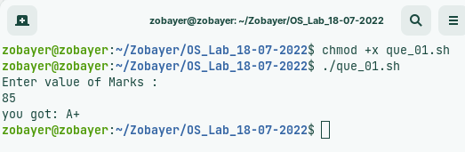then

echo "you got: A-"

elif [ $a -le 79 ]

then

echo "you got: A"

elif [ $a -le 100 ]

then

echo "you got: A+"

elif [ $a -gt 100 ]

then

echo "Please enter a number between 0 and 100, Thank You"

fi

**Question_02:** Write a bash file to determine vowel and consonant?

Code:

#!/bin/bash

read -p "Enter Letter to know vowel or consonant: " char

if [[ "$char" == *[AEIOUaeiou]* ]]; then

echo "vowel"

else

echo "consonant"

fi

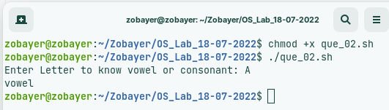

**Question_03:** Write a bash to file Check Prime number and non-prime Number?

Code:

#!/bin/bash

echo -e "Enter Number : \c"

read n

for((i=2; i<=$n/2; i++))

do

ans=$(( n%i ))

if [ $ans -eq 0 ]

then

echo "$n is not a prime number."

exit 0

fi

done

echo "$n is a prime number."

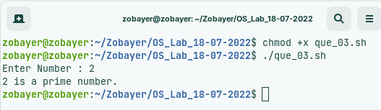

**Question_04:** Write a bash to file to show Fibonacci Series?

Code:

#!/bin/bash

n=10

a=0

b=1

echo "Fibonacci Series is here: "

for (( i=0; i<n; i++ ))

do

echo -e "$a"

c=$((a+b))

a=$b

b=$c

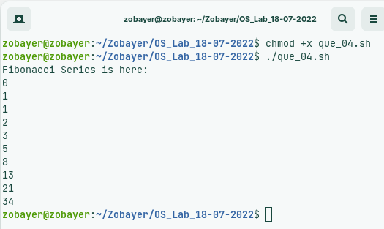done

**Question_05:** Write a bash to file Find the sum of Digit given number?

Code:

#!/bin/bash

echo "Enter a Number: "

read num

sum=0

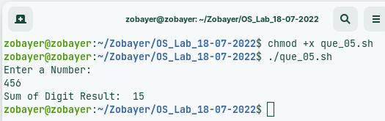while [ $num -gt 0 ]

do

mod=$((num % 10))

sum=$((sum + mod))

num=$((num / 10 ))

done

echo "Sum of Digit Result: " $sum